**PINBALL OPEN HOUSE**

**July 13, 2019**

**2pm until ???**





Come play the Prospector, Elvis and 20+ other machines and two Multicades.

 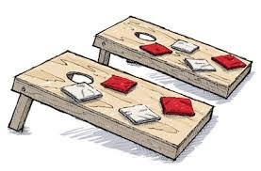

Come play in the pool or play some yard games.

Come by and socialize with other pinball players or make new friends.

Stop by for an hour or a few hours.

Food will be simple, Hot dog bar & meatballs with a few sides.

Sodas – BYOB

Please RSVP and for address - Rob Thomas – rw55dodgers@aol.com